Harris Corner Detection Lab lab task.
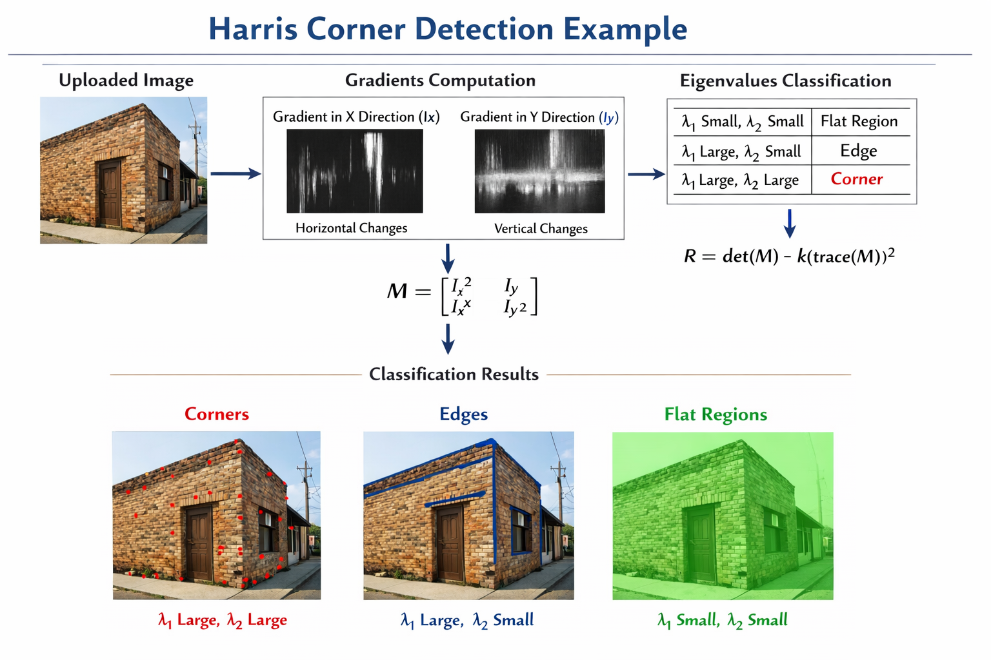
You want:
Student uploads an image → system detects → and labels pixels as
🟢 Flat
🔵 Edge
🔴 Corner
I will give you a complete working program that:
- Lets student upload image
- Computes Harris manually
- Classifies pixels using eigenvalue logic
- Displays:
  - Corner image
  - Edge image
  - Flat image
Everything explained clearly.

✅ 🔬 Full Interactive Harris Classification Code
This works in Google Colab

🔹 Step 1: Upload Image
from google.colab import files
import cv2
import numpy as np
import matplotlib.pyplot as plt
# Upload image
uploaded = files.upload()
# Read image
image_name = list(uploaded.keys())[0]
img = cv2.imread(image_name)
gray = cv2.cvtColor(img, cv2.COLOR_BGR2GRAY)
gray = np.float32(gray)
plt.imshow(cv2.cvtColor(img, cv2.COLOR_BGR2RGB))
plt.title("Uploaded Image")
plt.show()

🔹 Step 2: Compute Gradients
Ix = cv2.Sobel(gray, cv2.CV_64F, 1, 0, ksize=3)
Iy = cv2.Sobel(gray, cv2.CV_64F, 0, 1, ksize=3)
Explain :
- Ix → horizontal change
- Iy → vertical change

🔹 Step 3: Compute Structure Matrix Components
Ixx = Ix * Ix
Iyy = Iy * Iy
Ixy = Ix * Iy
Sxx = cv2.GaussianBlur(Ixx, (3,3), 1)
Syy = cv2.GaussianBlur(Iyy, (3,3), 1)
Sxy = cv2.GaussianBlur(Ixy, (3,3), 1)

🔹 Step 4: Compute Eigenvalues and Classify
Now we classify each pixel.
height, width = gray.shape
corner_img = img.copy()
edge_img = img.copy()
flat_img = img.copy()
threshold = 0.01
for y in range(height):
for x in range(width):
M = np.array([[Sxx[y,x], Sxy[y,x]],
[Sxy[y,x], Syy[y,x]]])
eigenvalues, _ = np.linalg.eig(M)
lambda1, lambda2 = eigenvalues
if lambda1 > threshold and lambda2 > threshold:
corner_img[y,x] = [0,0,255] # Red
elif (lambda1 > threshold and lambda2 <= threshold) or \
(lambda2 > threshold and lambda1 <= threshold):
edge_img[y,x] = [255,0,0] # Blue
else:
flat_img[y,x] = [0,255,0] # Green

🔹 Step 5: Show Results
plt.figure(figsize=(15,5))
plt.subplot(1,3,1)
plt.title("Corners (Red)")
plt.imshow(cv2.cvtColor(corner_img, cv2.COLOR_BGR2RGB))
plt.subplot(1,3,2)
plt.title("Edges (Blue)")
plt.imshow(cv2.cvtColor(edge_img, cv2.COLOR_BGR2RGB))
plt.subplot(1,3,3)
plt.title("Flat (Green)")
plt.imshow(cv2.cvtColor(flat_img, cv2.COLOR_BGR2RGB))
plt.show()

🎓 How This Works
We check eigenvalues:
λ1 | λ2 | Classification
small | small | Flat
large | small | Edge
large | large | Corner
So we are doing exactly theoretical definition.

🔥 Better Version (Faster)
The above double loop is slow for large images.
Here is a cleaner version using Harris R directly:
k = 0.04
R = (Sxx * Syy - Sxy**2) - k * (Sxx + Syy)**2
corner_img = img.copy()
edge_img = img.copy()
flat_img = img.copy()
corner_img[R > 0.01 * R.max()] = [0,0,255]
edge_img[(R < 0) & (R > -0.01 * R.max())] = [255,0,0]
flat_img[R == 0] = [0,255,0]

🧪 Lab Task
Ask them:
- Upload:
  - Building image
  - Road image
  - Crack image (good for your research 😉)
- Adjust threshold:
threshold = 0.02
- Observe:
  - How many corners?
  - What happens if image is blurred?

🎯 Final Important
Before running code, ask:
If I zoom image, will corners change?
Answer: Yes — Harris is not scale invariant.
Advanced students can later study:
- Scale-Invariant Feature Transform
- Speeded Up Robust Features

